The Weariness of Waiting
June 1, 2016

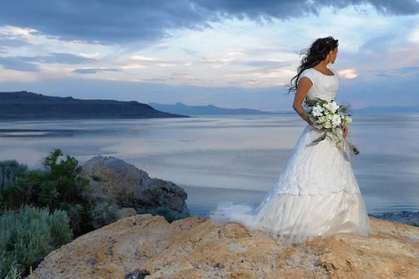
May the Lord impart His endless patience to our weary hearts.

Well, dear Heartdwellers, I have to admit I came into prayer extremely flat-lined and dry. Even my faith wavered…would the Lord speak to me when I am feeling so watered down? Then I realized, today is the first day of June. May has come and gone, and we are still here.

Yet, every day for the last two weeks the Lord is giving Ezekiel and I Scripture after Scripture about the Rapture and wedding feast of the Lamb, and being ready. For those of you who have been with us for over a year, you probably remember that He said it would not be years but months - and that was back in September. Then most lately, He said it is being held back minute by minute. But these minutes seem interminably long!

The day is gray here in Taos, and I have to say it reflects my weary heart.

"Lord, every single day for the last week or two You bring up Heaven and our wedding. Dreams about our wedding, visions about our wedding, Scriptures about it. Readings that I open to from our book that we've written about it. There hasn’t been a day lately that You haven’t mentioned something about a wedding or given us Scriptures about the Rapture. And yet I do struggle every day with wearying expectation."

The Lord answered me, "Are you wanting Me to answer this?"

No. I’m just saying...

"Come here, Clare."

I saw myself in the spirit leaning on His chest.

"You are not alone in this struggle. Not just you but others, too, and not just others but opposition, too. Anything to steal your incentive, your joy, your peace. But have you ever known Me not to keep a promise?"

Lord, I cannot say, because there are things that You have said that are unfulfilled as yet.

"In My Word, did I always fulfill My words to My Prophets?"

Absolutely. Although some of them were not alive to see the day...

"Well, you will be alive - that I have promised. The darkest hour is always before dawn. For many of you, My Brides, this is a dark hour, although you still have the necessities of life as it proceeds along. But for many it is a dark hour because you are laughed to scorn by your relatives, made fun of by those who watch your expectation of My return for you. Your hope will not be disappointed. Pay no mind to the whisperings and accusations of those who do not open their ears and their hearts to Me totally.

"Many are so riveted on the world they don't want to hear what I have to say. They don't want to hear My warnings. And yet they say, 'Where is the promise of His coming?' and you take a deep breath and tell them, 'The Bridegroom was delayed, but that does not mean He isn’t on His way.'

"Indeed, I am at the door - not on the way. 'On the way' was passed a long time ago. I am here now, holding out for yet another soul. Do I ever grow weary? To some that concept is blasphemous, but yes, I do grow weary. And all of you who are close to Me, My Brides especially, you know I am weary, because you, too, are weary and carrying this with you day after day.

"But because of My grace, you continue to persevere and hope against hope that I will fulfill this promise while you are yet alive. You continue to correct the selfish streak that wants it now, irregardless of those who are being brought to Me, and those who will perish in hell. You continue to put your hand in Mine and walk with Me beyond the pain of your weariness. And I commend you for that."

“There is no greater love than to lay down one's life for one's friends. And you are My friends if you do what I command. And this is My commandment, that you love one another as I have loved you." John 15

"And so, many of you are walking in this love, in great expectation. But you are growing weary. I am commending you, My Bride, for standing at My side in dryness, in physical trials, in scorn and contempt from your peers. Oh, how great will be your recompense in standing beside Me when so many are running away from Me into the world, when so many are slipping into the traps I warned them of as a one world government seeks to groom some and destroy others. As I follow the lost and the backslidden around, hoping they will just stop for one moment and consider their eternal destination before it is too late.

"Yes, I too am weary - very weary. Yet we hold out for just one more beloved son and daughter to return to Me. What shall I say, that the Day is coming? No, you have heard all that before. But I can tell you this: your reward in Heaven is very great. You have put on My garments of salvation and stood with Me in the dryness, in the testings, in the brutality leveled against you, some even losing their heads, only to gain an eternity with Me. Yes, an eternity with Me. Joys that you cannot reckon with the human mind.

"But for you who are still here, for you who persevere in climbing the mountain of holiness, I am taking you from glory to glory. You cannot see where you have come from or where you are going. You only look to My hand, following Me wherever I go, seeking Me out each day, hungering to know My will and to live for Me. Yes, for you the journey is long, dry and hard. But when you finally stand on that mountain top and take in the view, you will count all your sufferings as nothing. And like a woman who has brought forth a man-child, you will forget the long and intense labor for the joy of holding the newborn child in your arms.

"I have little more to say to you, My Brides - except that you are My co-laborers in the vineyard. You stand by My side in expectation of that Day, and I tell you the truth: your hope will not be disappointed and your reward will be great."

